AWS CodeBuild Integration with CodeCommit – Complete Guide

Introduction
- In this lesson, we'll explore AWS CodeBuild and learn how to integrate it with a CodeCommit repository to automate the build process.

- AWS CodeBuild is a fully managed continuous integration service that compiles source code, runs tests, and produces deployment-ready artifacts. One of its major advantages is elastic scaling, where you pay only for the build time consumed.

Step 1: Create a CodeBuild Project

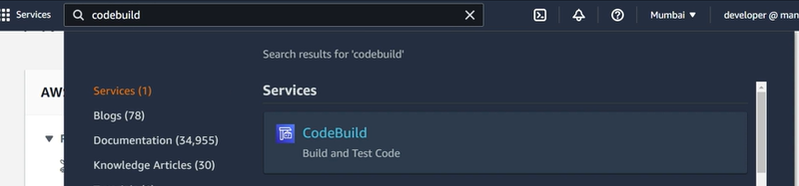
- Navigate to AWS CodeBuild from the AWS Management Console and select Create Project.

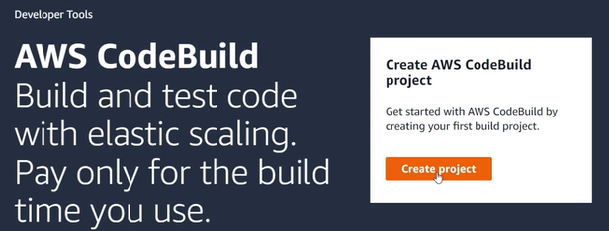

Project Configuration
Configure the following:
- Project Name: AWS-CodeBuild-First
- Description: Optional
- Build Badge: Optional
- Tags: Optional for identifying projects

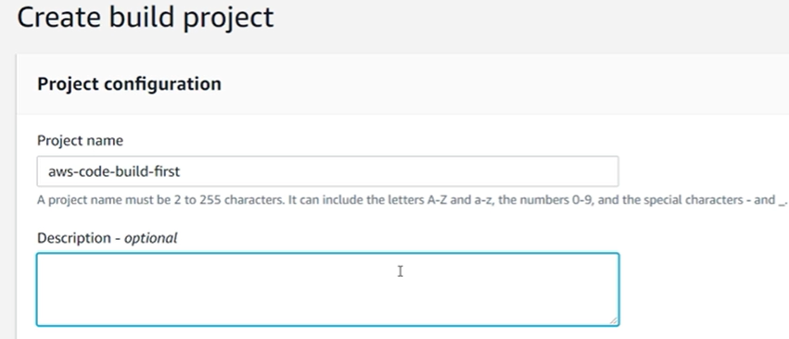

Step 2: Configure the Source Repository

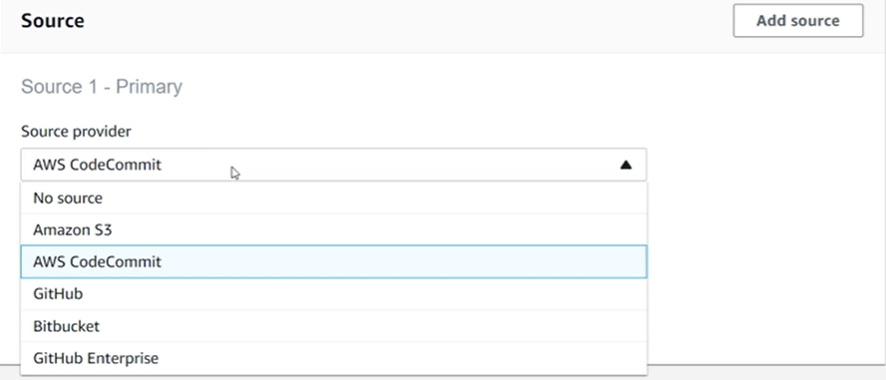
CodeBuild supports multiple source providers, including:
- AWS CodeCommit
- Amazon S3
- GitHub
- GitHub Enterprise
- Bitbucket
Since our source code is stored in CodeCommit, select:
Source Provider: AWS CodeCommit

Step 3: Create a CodeCommit Repository
Before connecting CodeBuild, create a repository in CodeCommit.
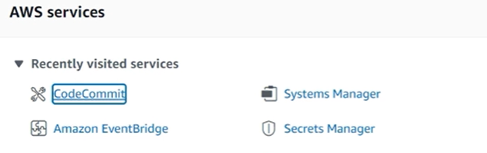

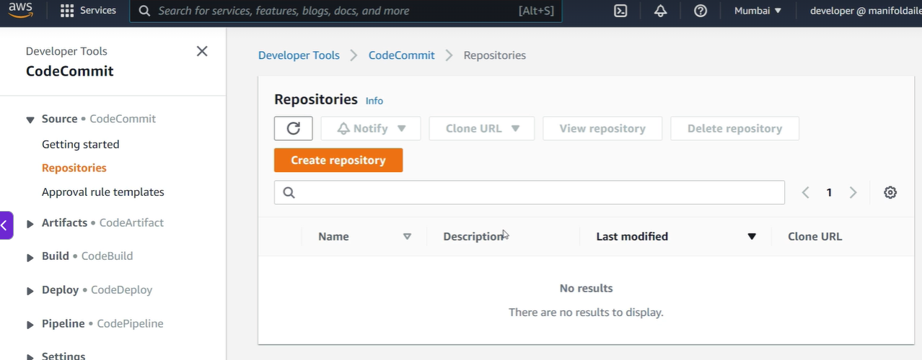

Repository Details
Repository Name: codebuild-repo
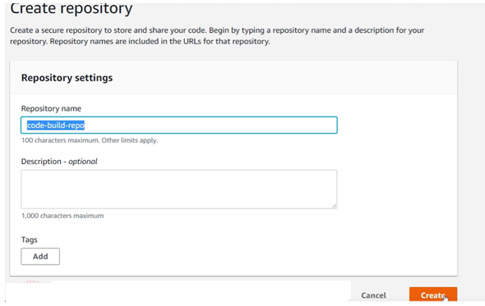
Once created, push your application code into the repository using Git.
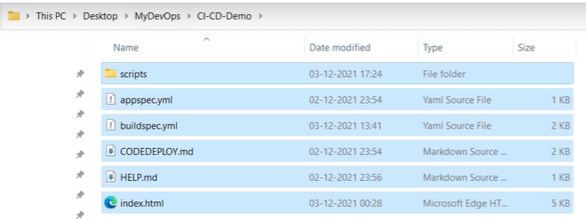

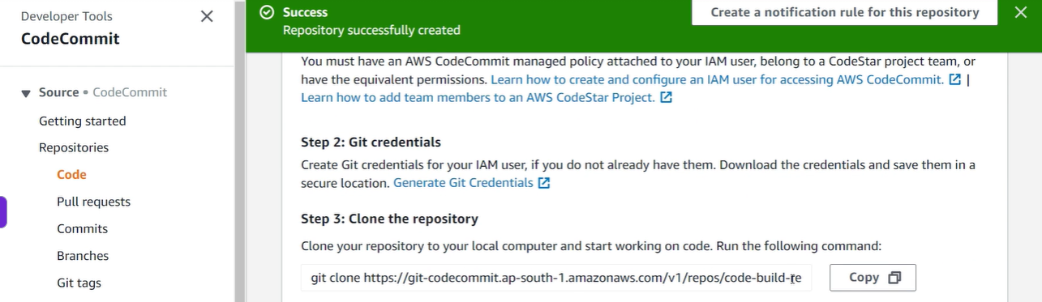
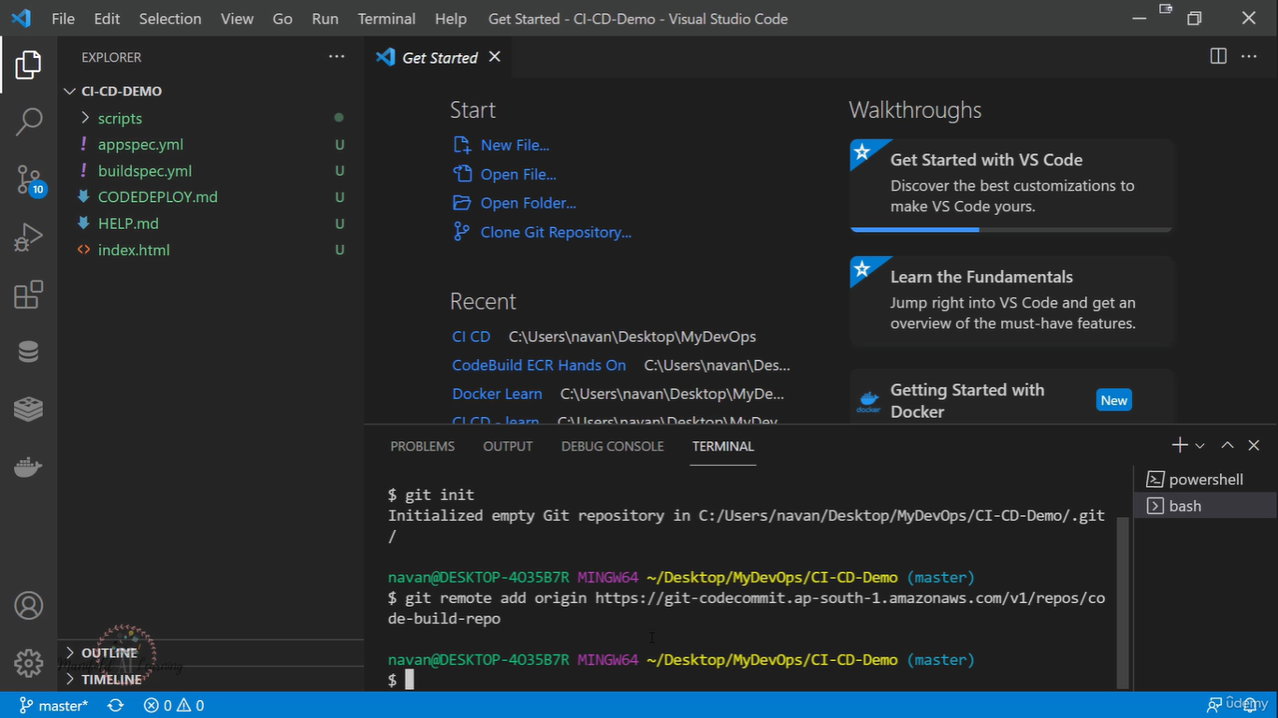

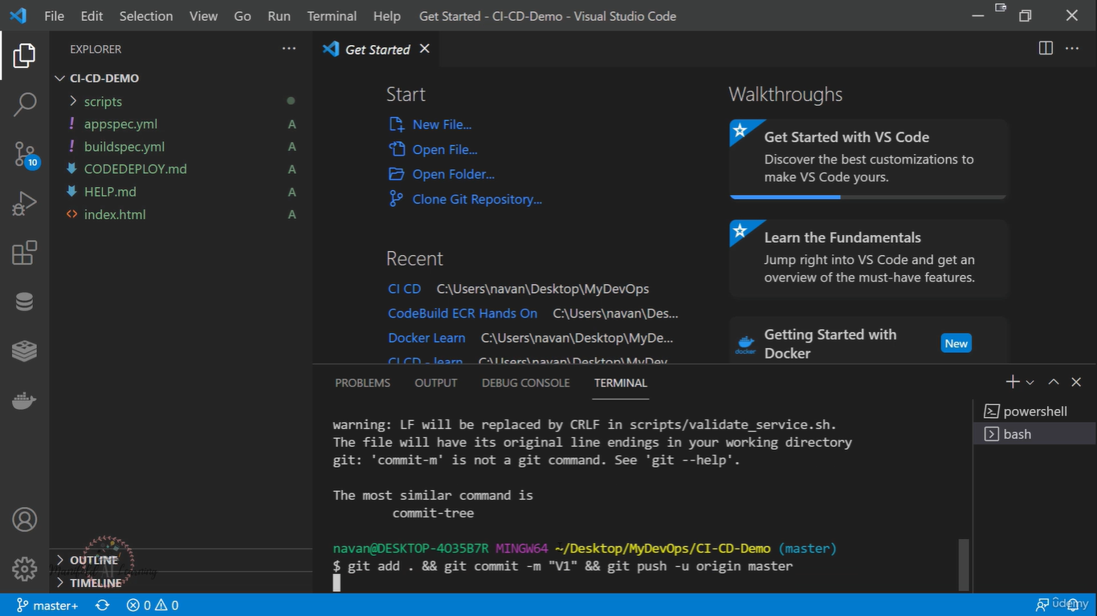

Git Commands
git init

git remote add origin <repository-url>

git add .

git commit -m "v1"

git push -u origin master

After pushing the code, verify that the files are visible inside the CodeCommit repository.
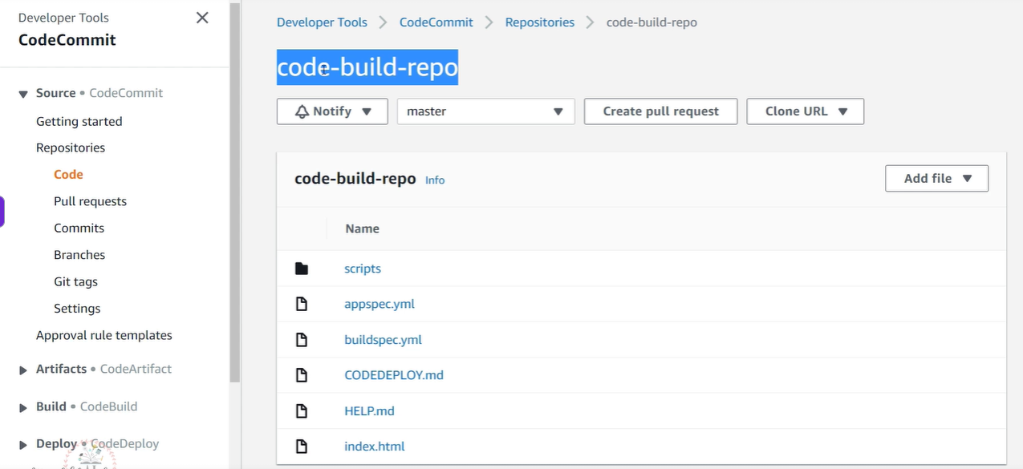

Step 4: Connect CodeBuild to CodeCommit
Return to the CodeBuild project configuration.

Source Settings
- Source Provider: AWS CodeCommit
- Repository: codebuild-repo
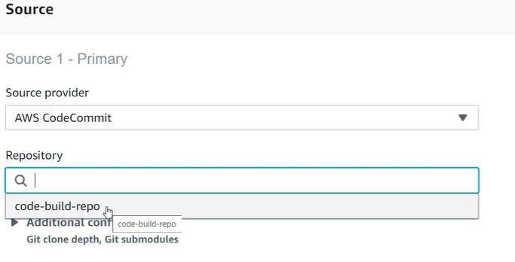
- Branch: master
CodeBuild allows builds to be triggered from:
- Specific branches
- Git tags
- Commit IDs
This flexibility enables separate build projects for:
- Production branch
- Development branch
- Feature branches

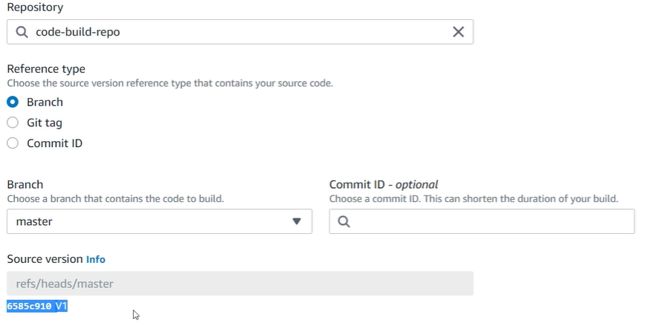

Step 5: Configure the Build Environment
CodeBuild offers two environment options:

AWS Managed Environment
AWS provides preconfigured build environments.

Custom Docker Image
You can provide your own Docker image for specialized requirements.

Example Configuration
Setting | Value
Operating System | Amazon Linux 2
Runtime | Standard
Image Version | Latest
Privileged Mode | Disabled
Enable Privileged Mode only when building Docker images.

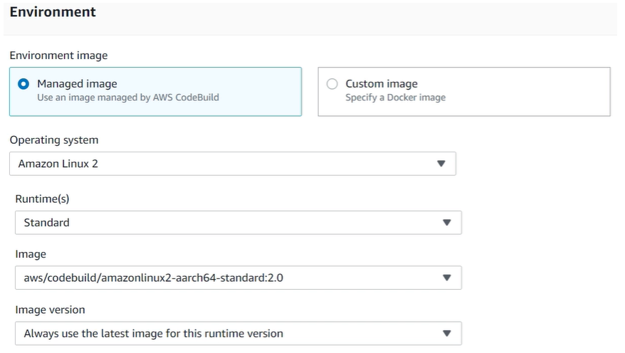

Step 6: Configure IAM Permissions
Allow CodeBuild to create a new service role automatically.
This IAM role grants the permissions required to:
- Access CodeCommit
- Retrieve source code
- Generate logs
- Execute build operations

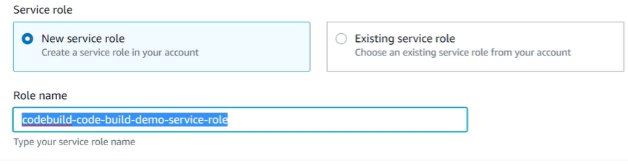

Step 7: Configure Build Specification
CodeBuild requires a buildspec.yml file.
This file defines:
- Installation steps
- Pre-build actions
- Build commands
- Post-build activities
For now, use:
buildspec.yml
as the build specification file.
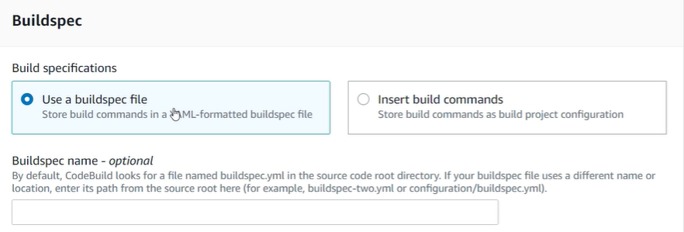

Step 8: Configure Artifacts
Artifacts are the output files generated by the build process.
Examples:
- ZIP packages
- Compiled binaries
- Deployment bundles
For this demonstration:
Artifacts = No Artifacts

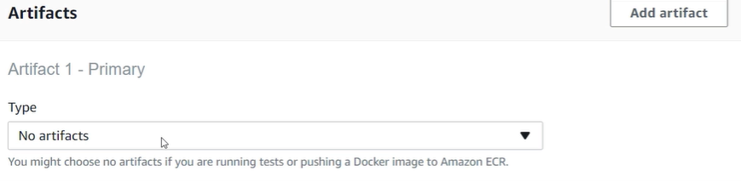

Step 9: Enable Logging
Enable Amazon CloudWatch Logs.
Benefits:
- Troubleshooting build failures
- Monitoring build execution
- Reviewing build outputs

Step 10: Create and Start the Build
After reviewing all configurations:
- Click Create Build Project
- Select Start Build
CodeBuild will now:
- Fetch code from CodeCommit
- Provision build resources
- Execute build steps
- Generate logs
- Report build status

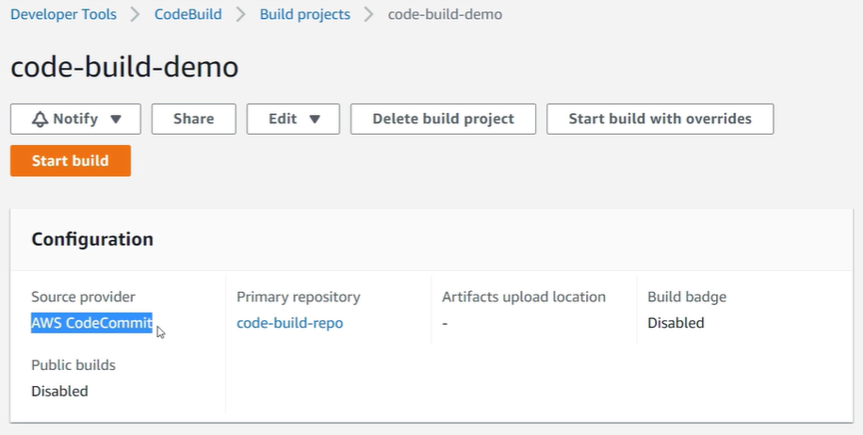

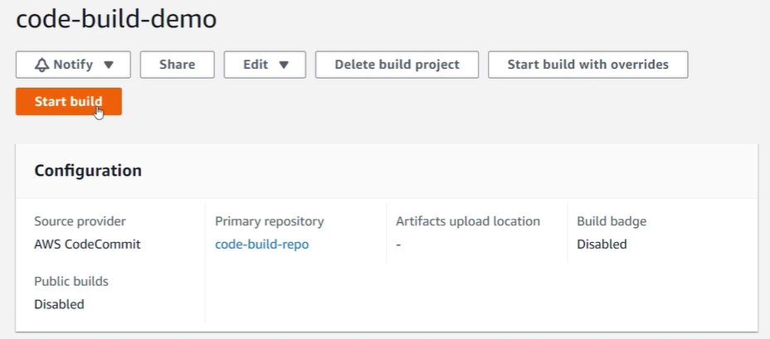

Understanding the Build Lifecycle
A CodeBuild execution passes through multiple stages.

Build Phases
Phase | Purpose
Submitted | Build request received
Queued | Waiting for resources
Provisioning | Allocating build environment
Download Source | Fetching code from repository
Install | Installing dependencies
Pre-Build | Running preparation tasks
Build | Compiling or processing code
Post-Build | Running cleanup or deployment steps
Upload Artifacts | Uploading generated outputs
Finalizing | Completing build operations
Completed | Build finished

Understanding buildspec.yml
The buildspec.yml file is the heart of AWS CodeBuild.
Example structure:
version: 0.2
env:
variables:
AWS_REGION: ap-south-1
phases:
install:
commands:
- echo "Starting installation process"
pre_build:
commands:
- echo "Pre-build phase started"
build:
commands:
- echo "Building application"
post_build:
commands:
- echo "Build completed successfully"

Key Components of buildspec.yml

Version
Defines the build specification version.
version: 0.2

Environment Variables
Store reusable configuration values.
env:
variables:
AWS_REGION: ap-south-1

Install Phase
Used for:
- Installing packages
- Configuring runtime dependencies
- Setting up tools
Example:
install:
commands:
- echo "Installing dependencies"

Pre-Build Phase
Executed before the actual build begins.
Example:
pre_build:
commands:
- echo "Preparing build environment"

Build Phase
Contains the main build commands.
Example:
build:
commands:
- echo "Compiling application"

Post-Build Phase
Runs after a successful build.
Example:
post_build:
commands:
- echo "Build completed"

Build Logs and Output
During execution, CloudWatch displays messages generated from the buildspec.yml file.
Example logs:
Running on ap-south-1
Starting installation process
Installation complete
Pre-build phase started
Build phase started
Post-build phase completed
These logs help developers understand what happened during each stage of the build.

Key Takeaways
- AWS CodeBuild automates application build processes.
- CodeBuild integrates directly with AWS CodeCommit.
- Source code is pulled from a selected repository and branch.
- AWS-managed build environments simplify setup.
- CloudWatch Logs provide visibility into build execution.
- The buildspec.yml file controls every stage of the build lifecycle.
- Understanding buildspec.yml is essential for working effectively with AWS CI/CD pipelines.

Architecture Overview
Developer
↓
AWS CodeCommit
↓
AWS CodeBuild
↓
Build Environment
↓
Build Logs (CloudWatch)
↓
Artifacts / Deployment Package

